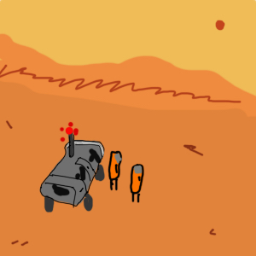**Mars**Tom Kent-Peterson

Adam Munro  
Lorne Brooks  
Finn Luxton  
  
January 2018

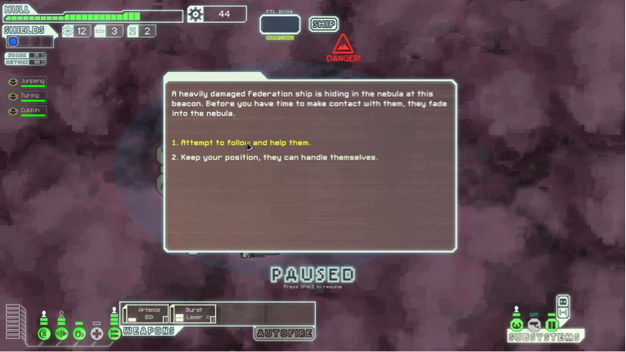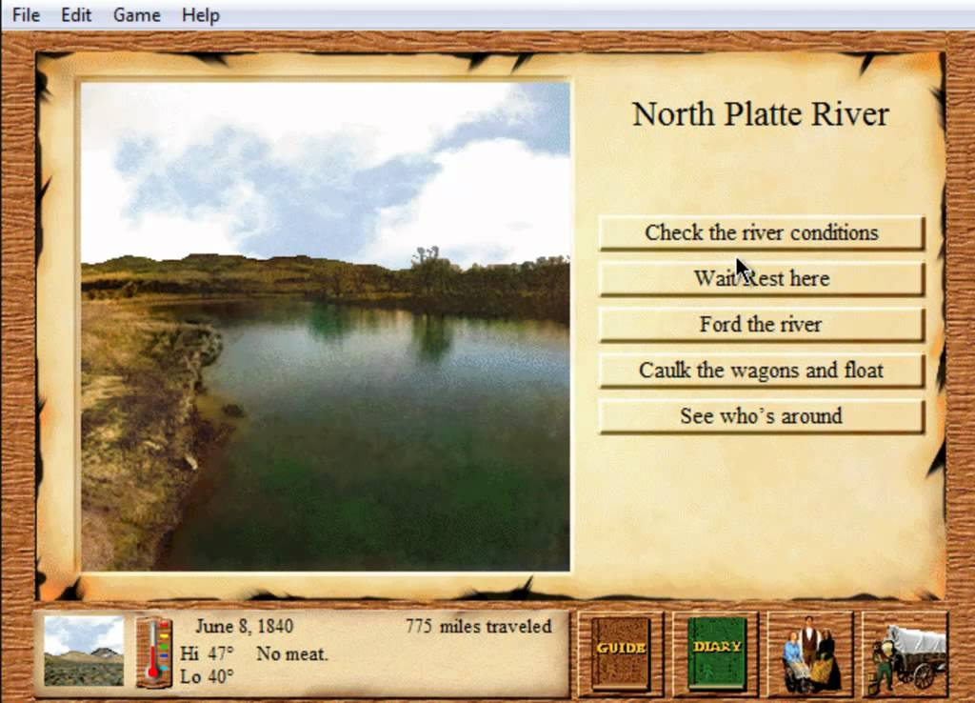

Mars is a resource management and decision making game set in the style of Oregon Trail. The player will have to lead their survivors to safetyas they traverse across the arid wasteland of mars.  
The gameplay works

The different survivors the player controls will have unique traits, which affect the choices and the outcome of these events, for example Survivors with the claustrophobic trait would not enter caves

The player will be pressured into taking risker choices, by taking their current situation into account. For example, an event would require the player’s survivors to engage or disengage in combat. If the survivors are heavily injured,

**Overview**

**[GAME TITLE]** is set on a colonized mars, whereas the player controls a team of 6 survivors, who evacuated from their station after it was destroyed by a freak solar dust storm. The survivors are all unique with their own portraits, names and bios, and also possessing traits and skills that will affect how that survivor interacts decisions made by the player.

The game begins with a starting location, and a destination with a timer set for X amount of days. Once the timer reaches 0, the brunt of the freak solar dust storm lays waste to the planet, meaning certain death on the surface.